

Technology Management

Assignment 3

Section A

Zaid Mustafa

22-10249

Waqas Rasheed

22-11004

Hatib Zubair

241547206

Project Names 3

Project Management Software 4

Tasks 4

Kanban 5

Deadline 6

Planner 7

Calendar 8

Gantt Chart 11

Scrum Team 14

Anti-Virus Software 17

Tasks 17

Kanban 17

Deadline 18

Planner 18

Calendar 19

Gantt Chart 21

Scrum Team 22

# Project Names

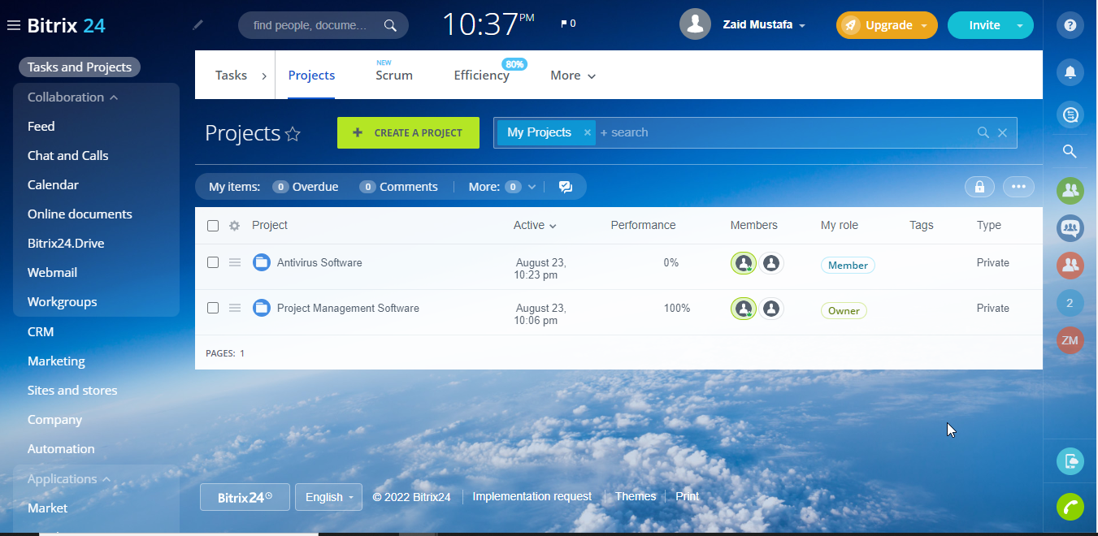

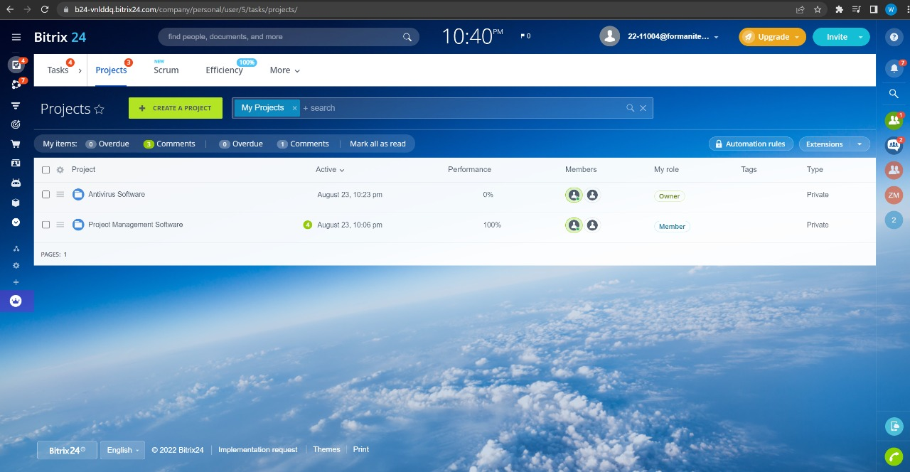

# Project Management Software

## Tasks

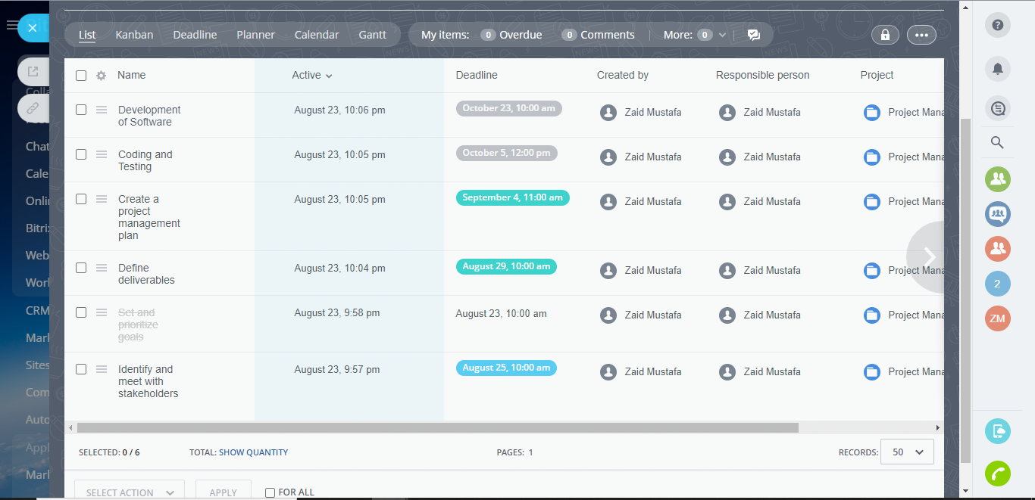

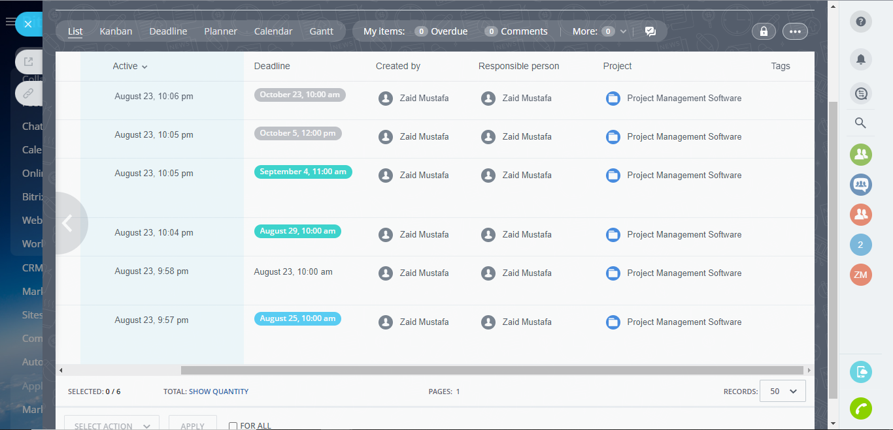

## Kanban

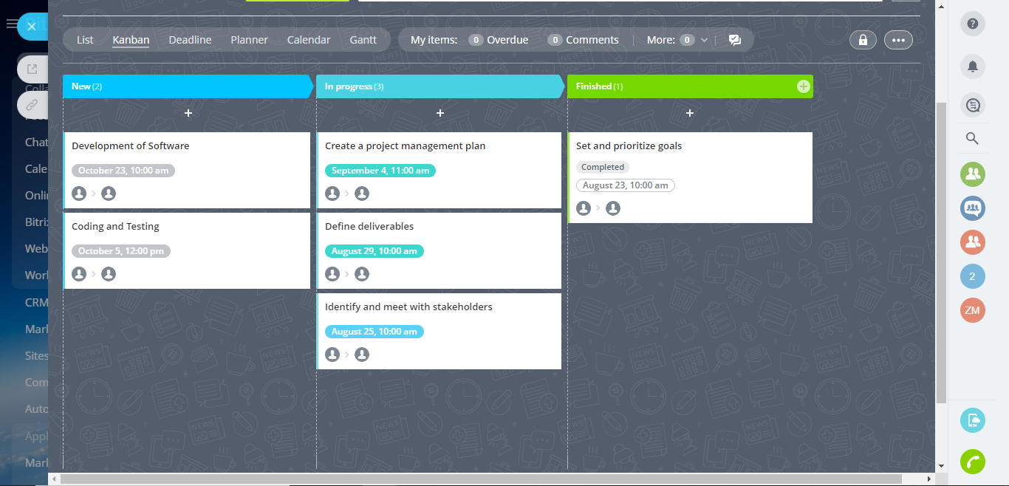

## Deadline

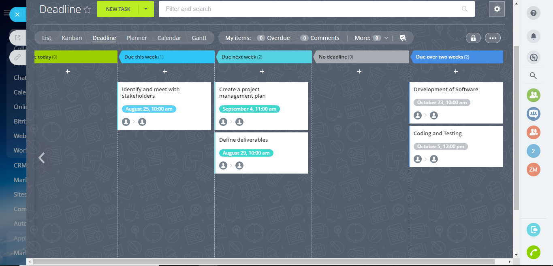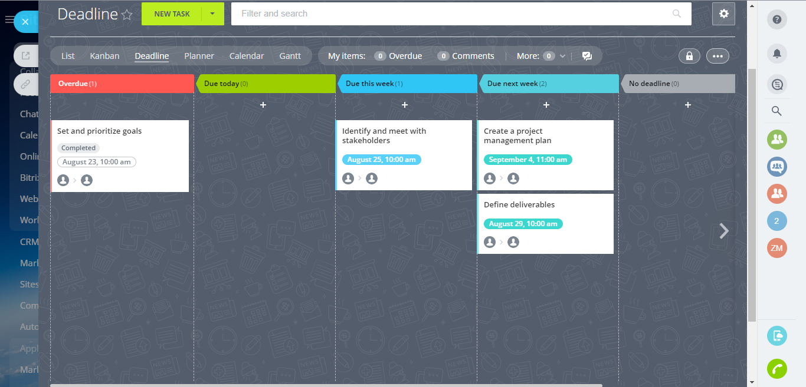

## Planner

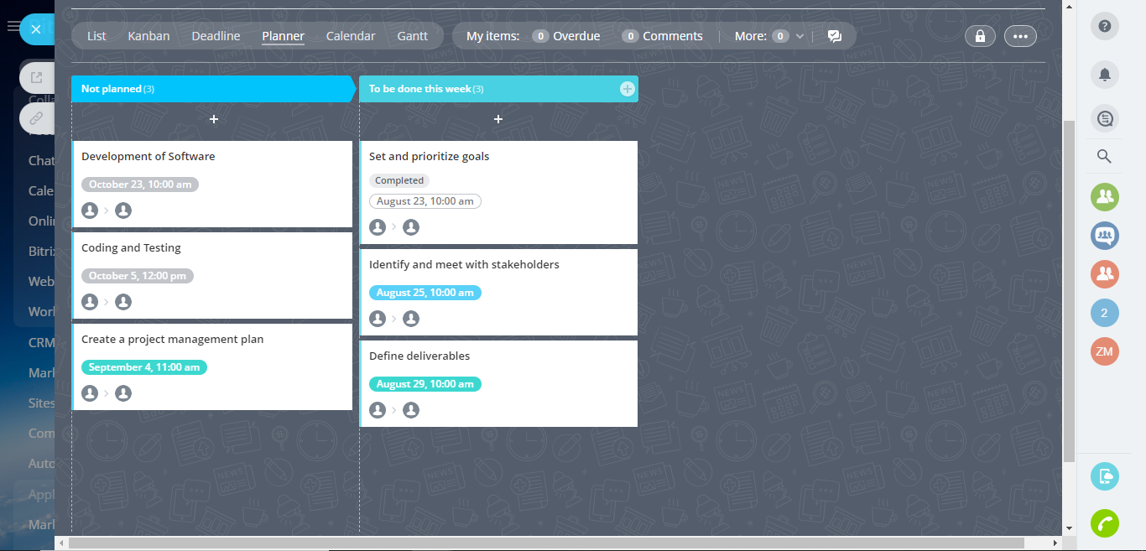

## Calendar

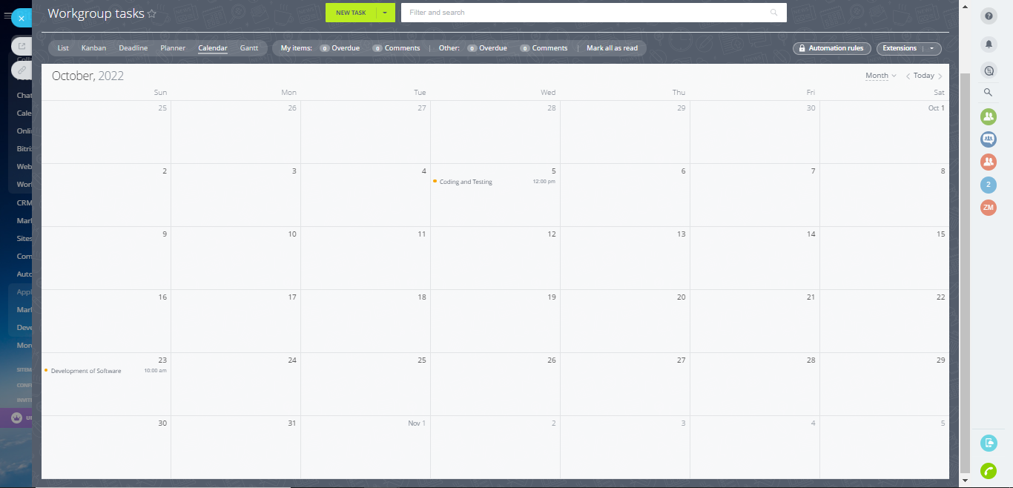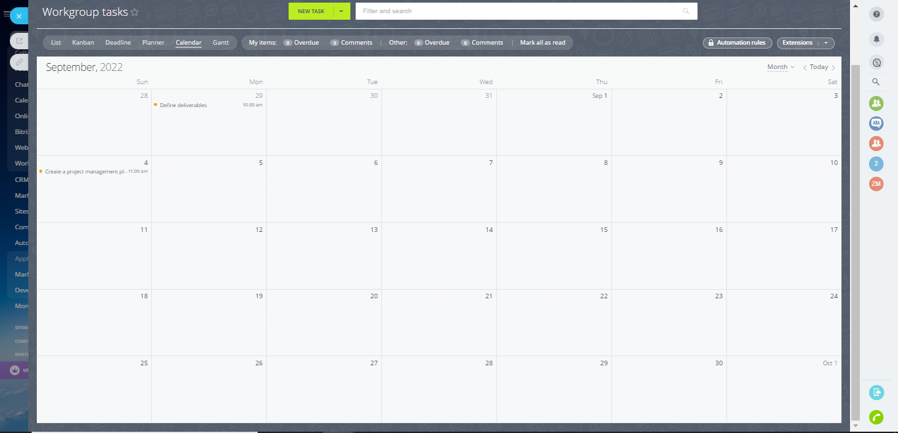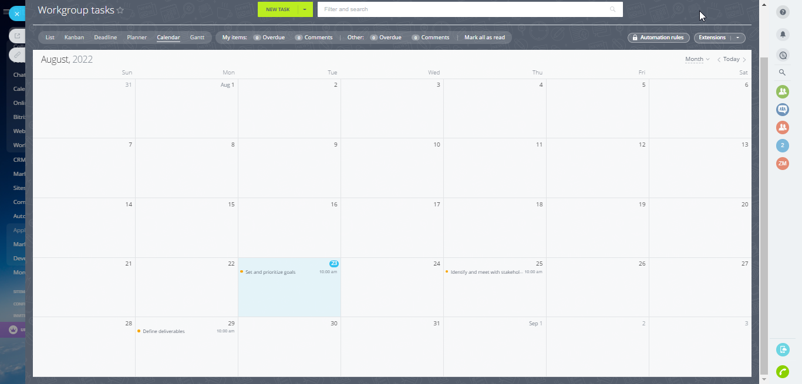

## Gantt Chart

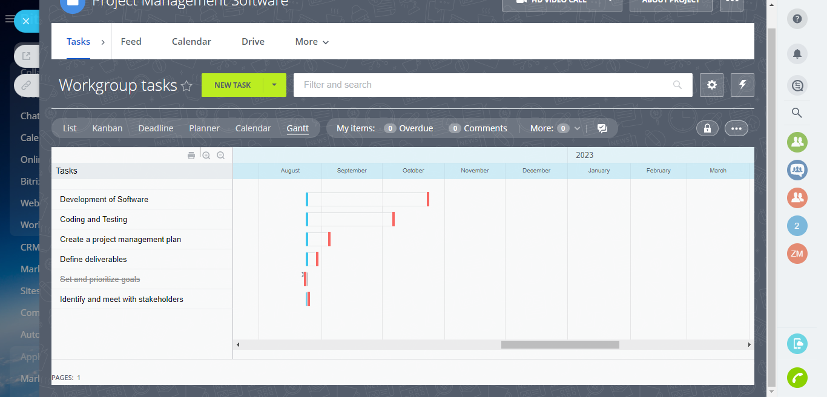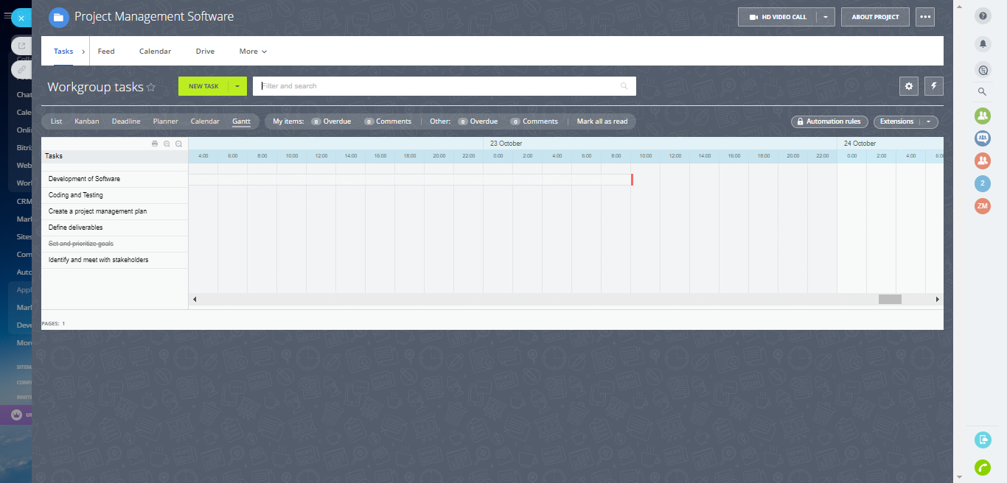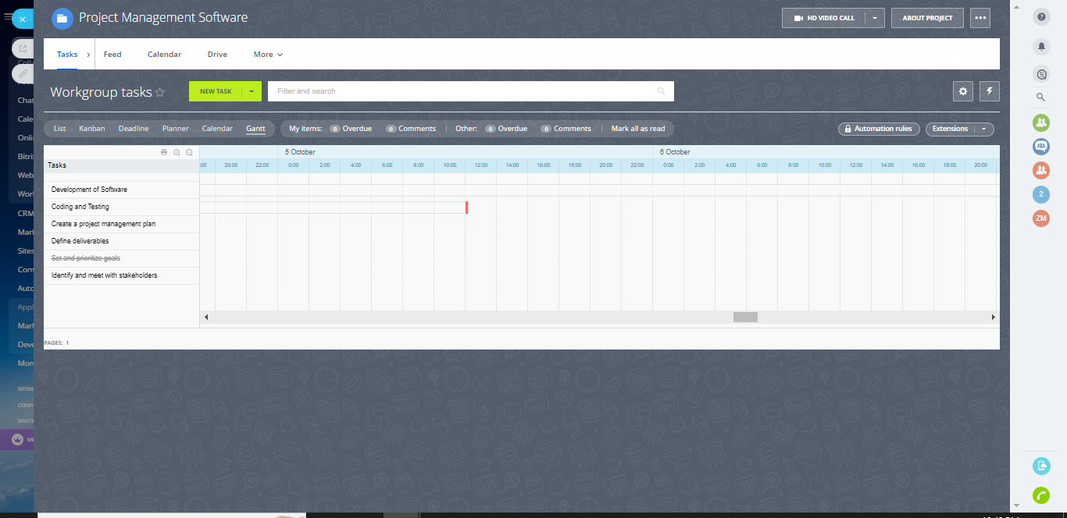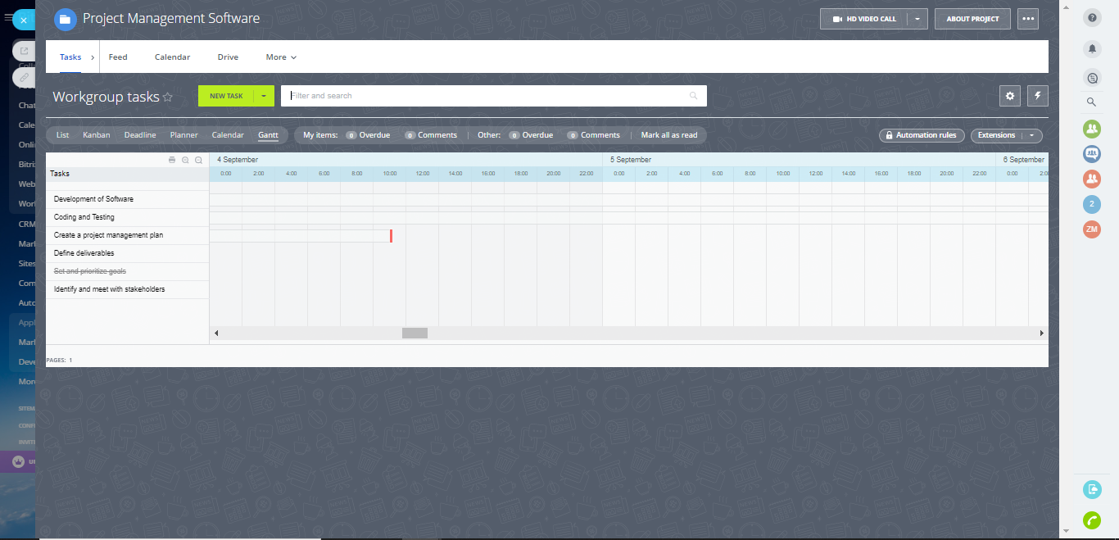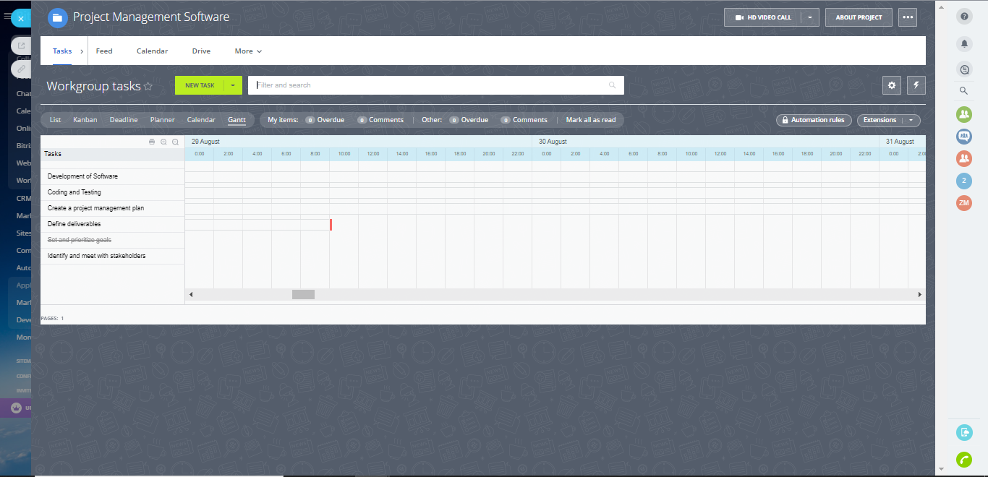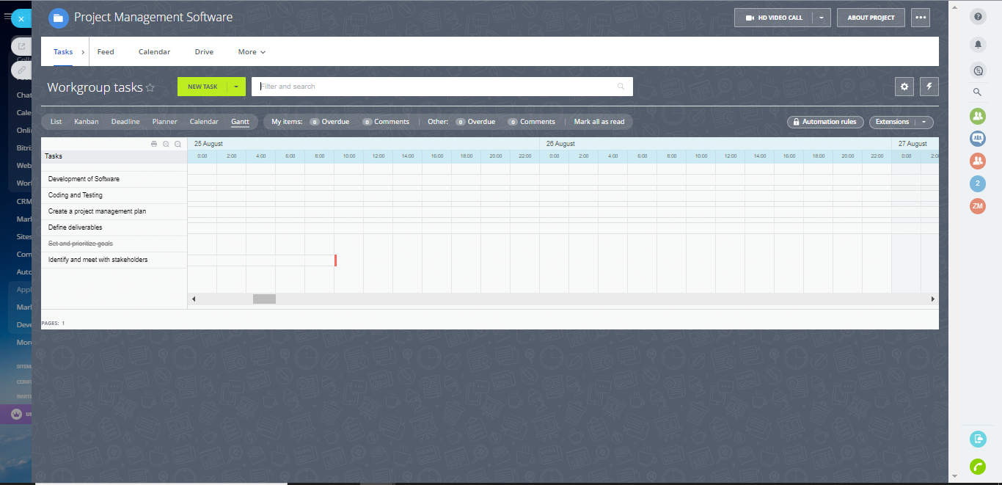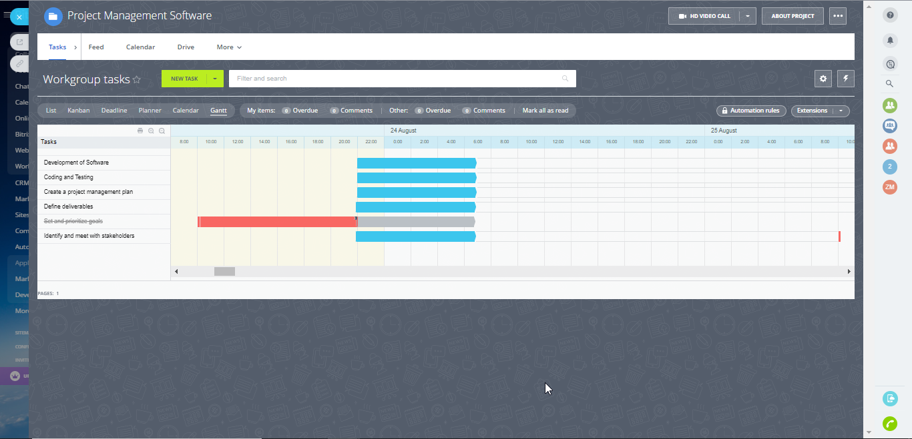

# Scrum Team

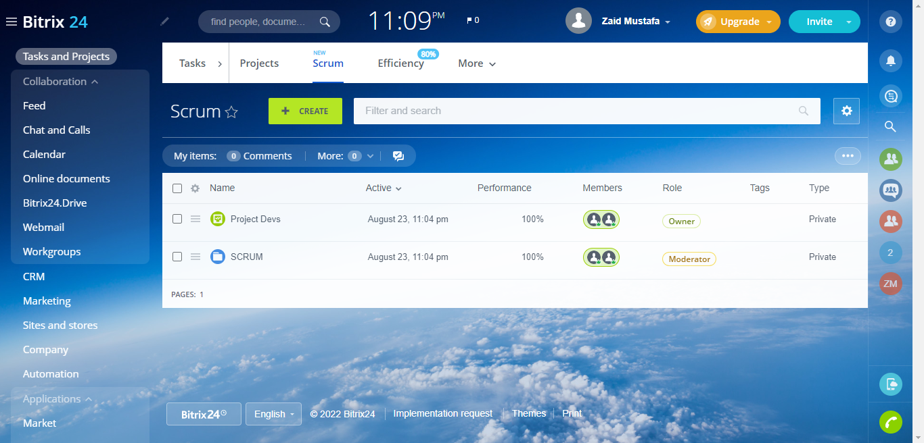

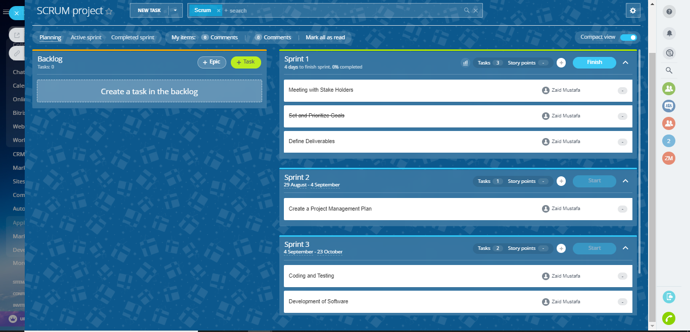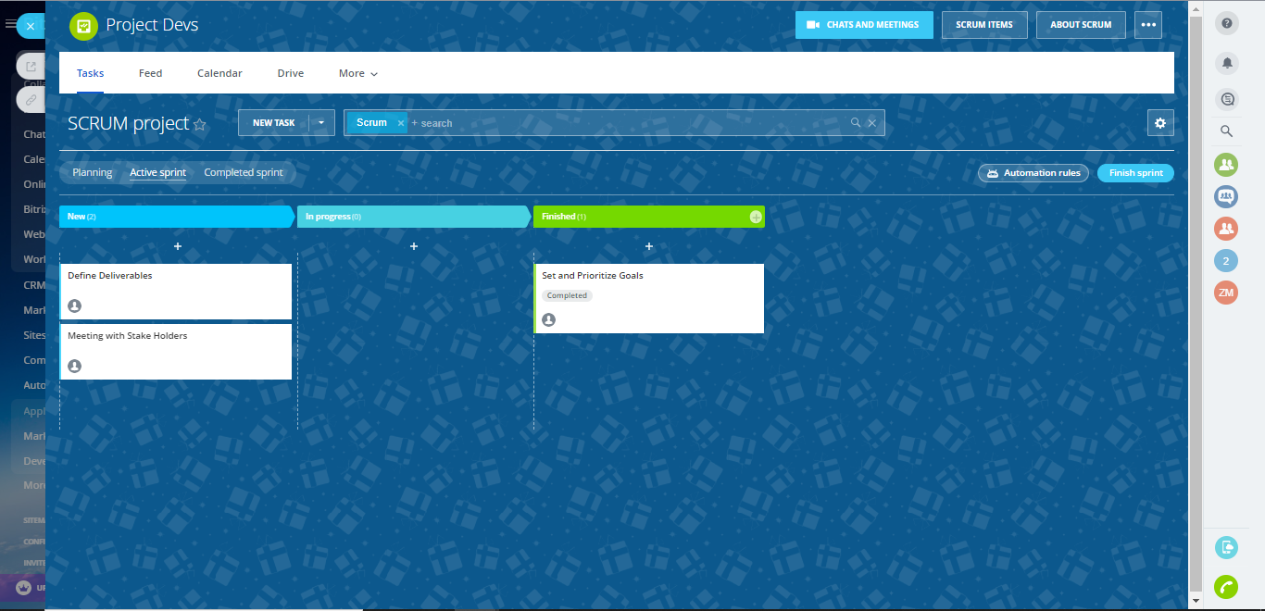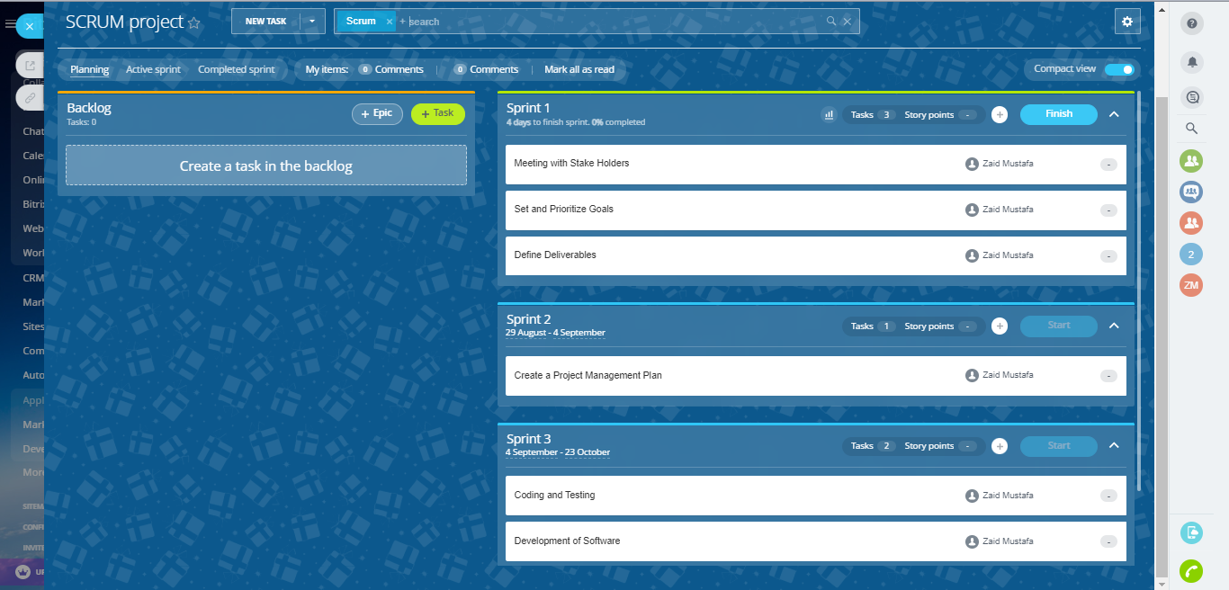

# Anti-Virus Software

## Tasks

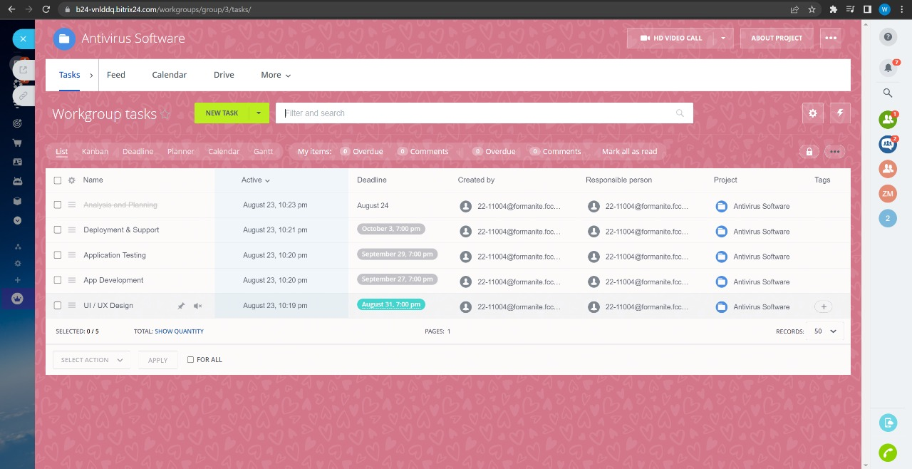

## Kanban

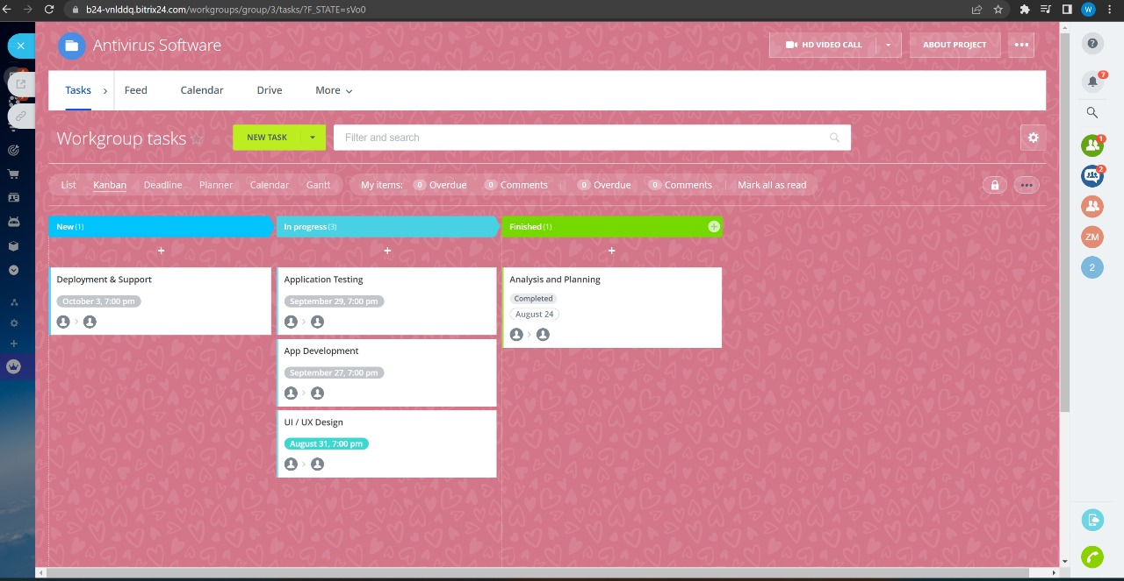

## Deadline

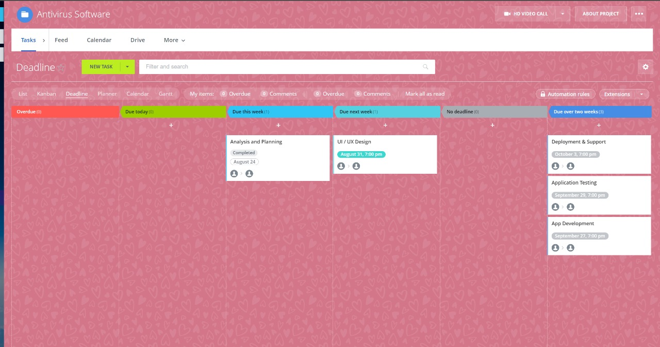

## Planner

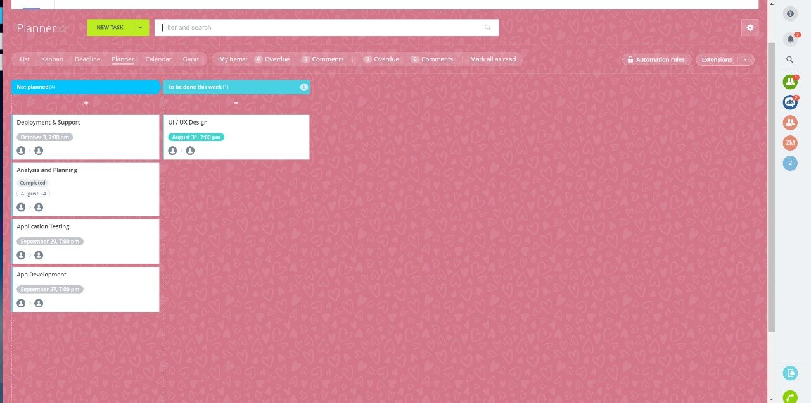

## Calendar

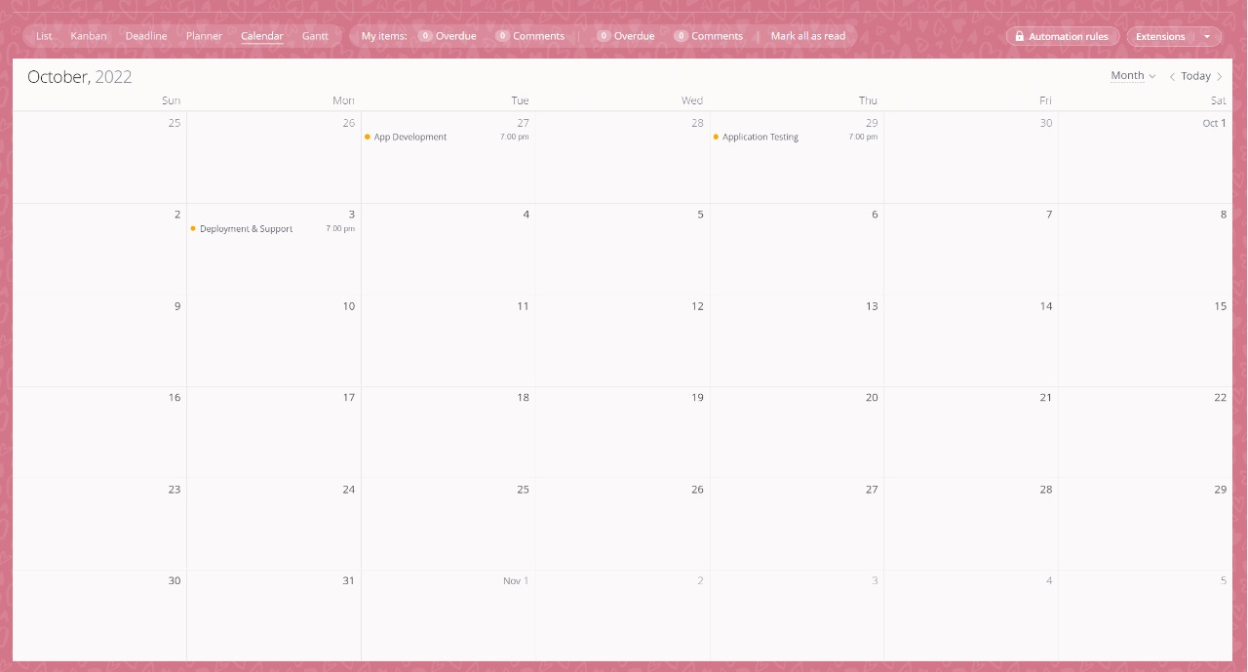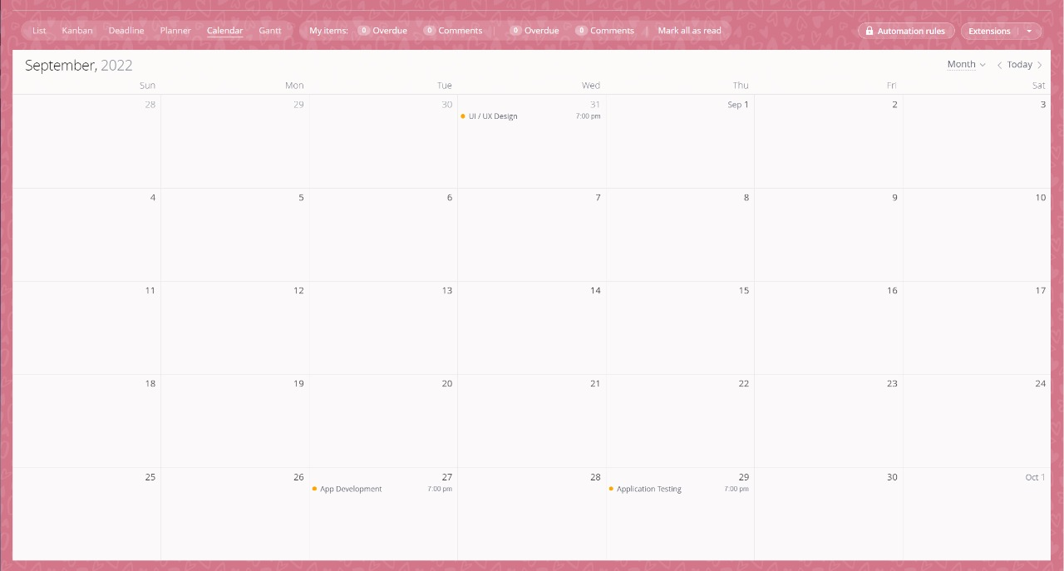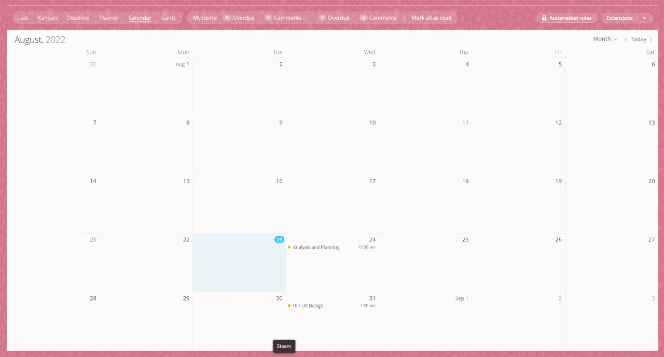

## Gantt Chart

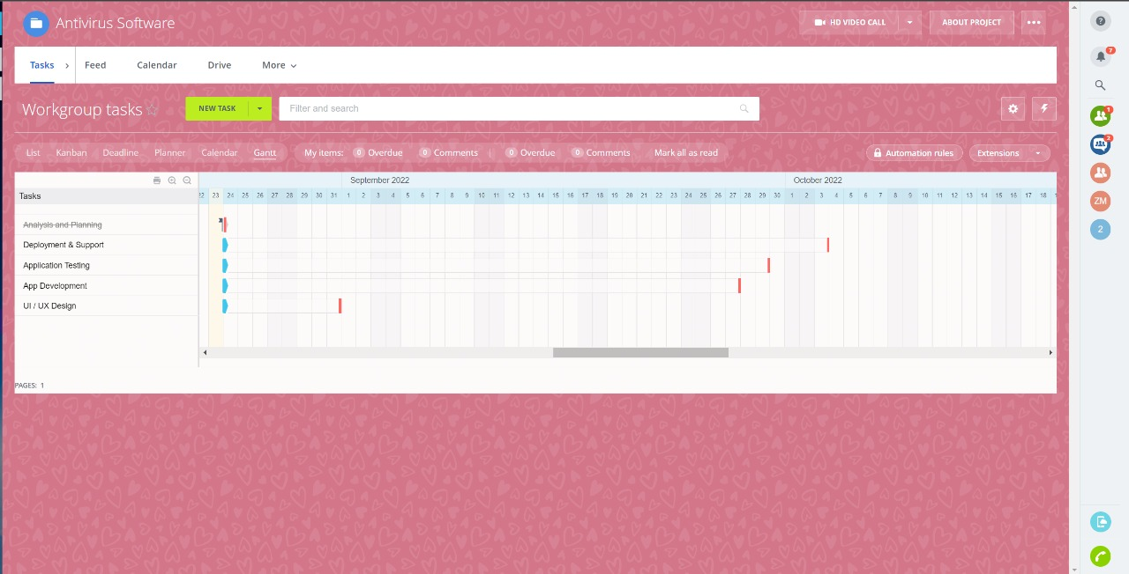

# Scrum Team

